

**The Avril Lavigne Foundation Identity Usage Guidelines**

**1. Logo.** The Avril Lavigne Foundation is below. The logo should not change colors or be used in black in white except in the case of printing non-public facing documents.

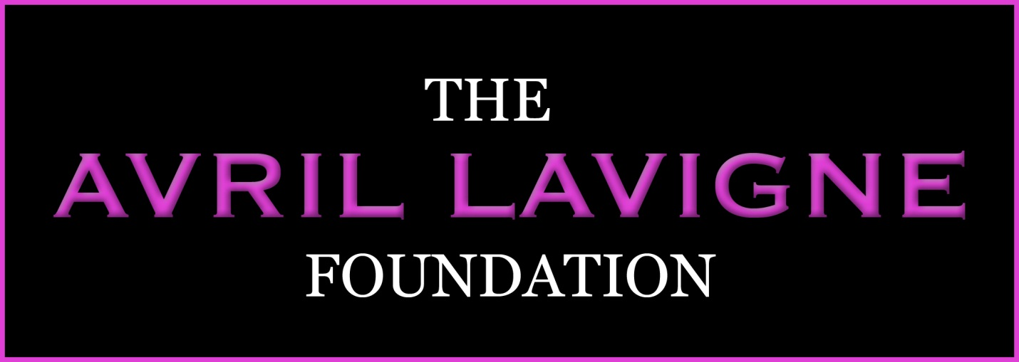

**2. Colors.** In general the colors of the Avril Lavigne Foundation are pink (magentas, bright and darker pinks versus light pinks or purples) and black and white. A range of variations on this shade are permitted, so long as they match the logo.

**3. Typeface.** The Foundation typically uses San Serif fonts including Corbel or Century gothic. Variations on San Serif fonts are OK.

**4. Name**. The Avril Lavigne Foundation should always be named as “The Avril Lavigne Foundation, and not “Avril Foundation” or “The Avril Foundation” with the exception of character-limited social media postings.